Creating Events and Volunteer Sign-Up Lists

This is how you create a new event within Clubrunner, and also how you send out an email asking for volunteers.

This particular example shows how to set up a volunteer sign-up list associated with artists, billets, etc. – a list that has no time slots.

To create a volunteer sign-up list that DOES use time slots, under #9, enter times rather than leaving them blank.

For more assistance, call me or talk to any of the club members who have experience in creating events and volunteer sign-up lists.

Wayne Overbo

- Click on Edit Events

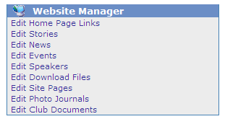

- Click on Add New Event

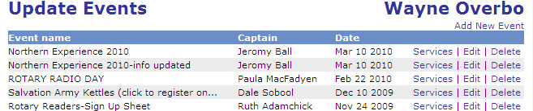

- Enter an “Event Name”, “Details” and “Captain”. Don’t fill in any of the other blanks but make sure the buttons at the bottom say:
  - Yes - Allow online registration
  - Yes - Email the captain every time
  - Yes – Send email confirmations
  - No – Show in Bulletin
  - No – Show in District Event Calendar
  - Then click Save

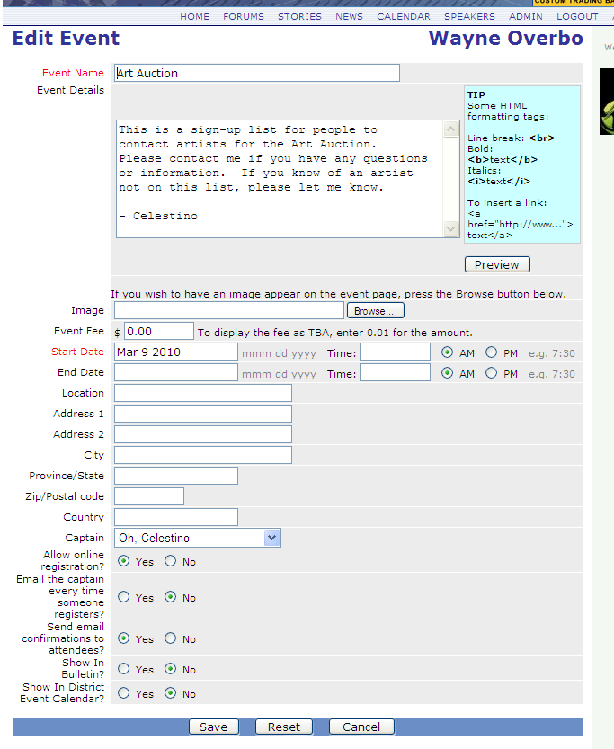

- Find your event and click on Services

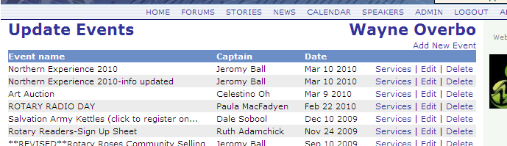

- Click on Tasks & Volunteers Management

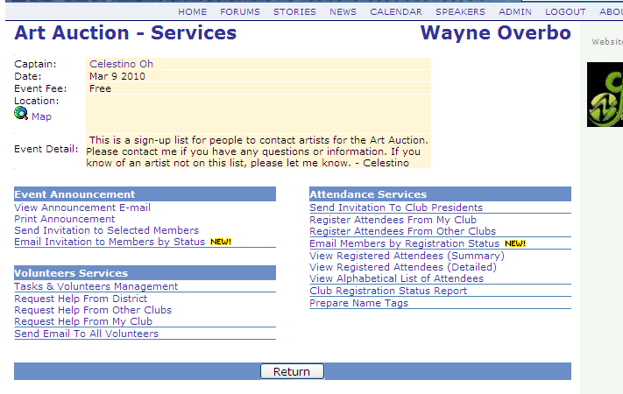

- Click on Add New Task

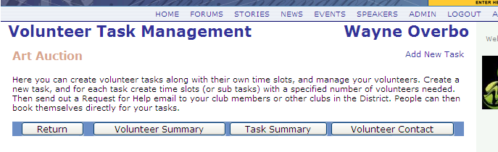

- Choose a name for this task (this task is within your event) and choose a chair (can be you or can be someone else). The phone and email information comes up automatically from the club directory when you pick a name, but it can also be manually changed. When this is all done click Save.

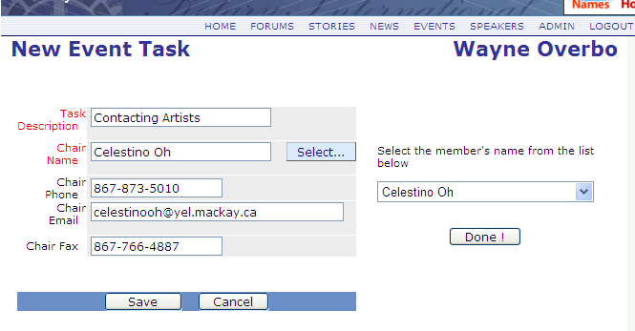

- Click on “Add New Time Slot”

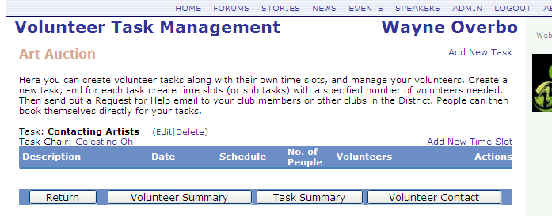

- Under Description, enter the artist’s name. Leave the date as it is (today’s date) and don’t enter any time information. Then, enter the number of people you want to sign up for each artist – probably one. When this is all done click Save.

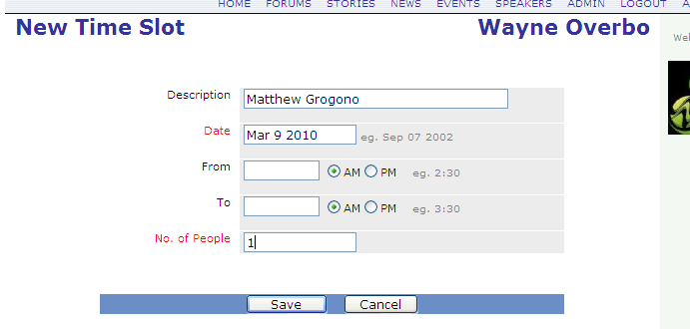

- Repeat this for every artist and you will get a list that looks like this:

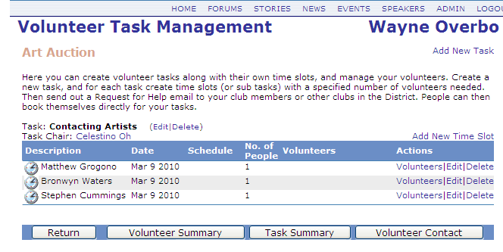

- Click Return and you will be back at this screen:

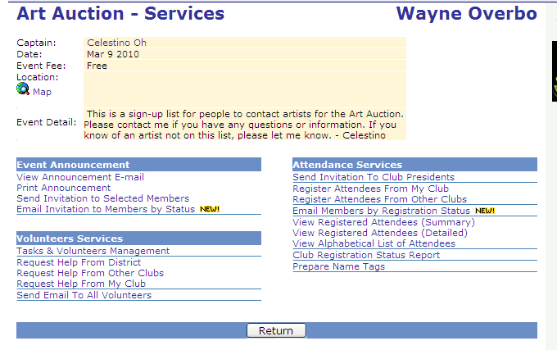

- Click on “Request Help From My Club”. You will be taken to this screen:

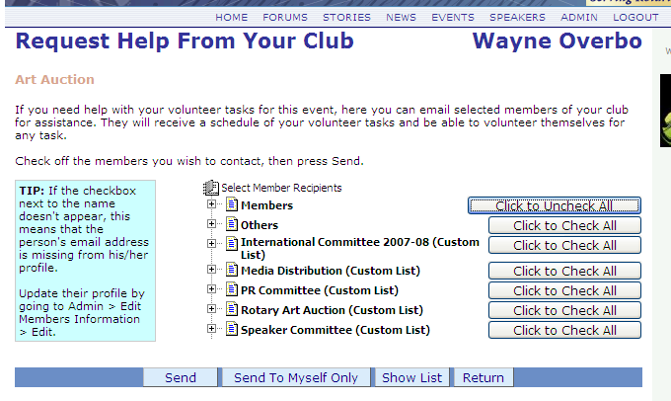

- Choose “Click to Check All” for the Members list, just like when you send a regular email. Then click the Send button.
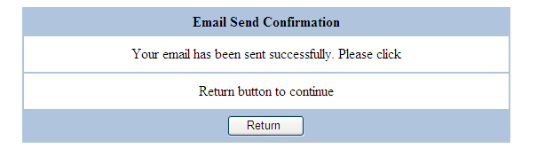

- Each member will get an email that looks like this, and you are done!

